Puzzle grids – feel free to resize as needed

Last weeks answer key:

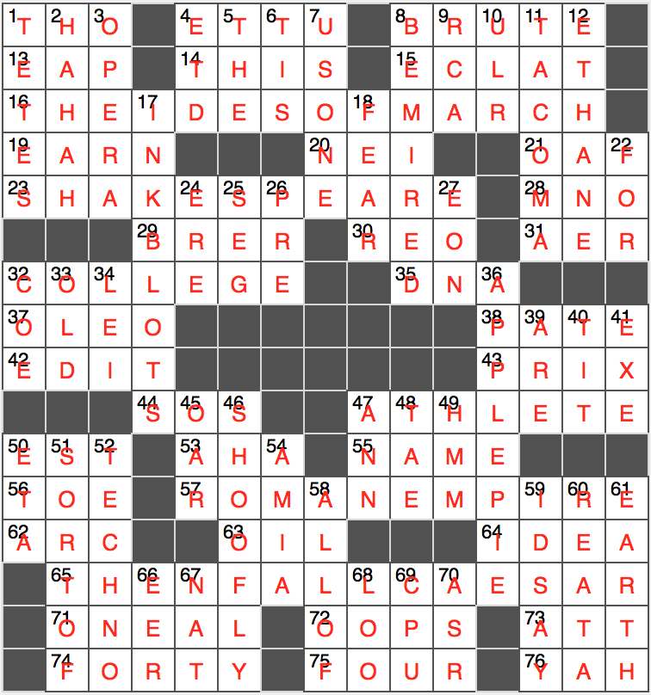

This week’s crossword grid:

